**1.1 Introduction:**

A proper Restaurant management system is very much needed for handling all the stage of any restaurant. The objective of this report is to give the overview of the implementation of our system.

Implementation is the action that should follow in any preliminary thinking in order of something to actually happen. It encompasses all the processes involved in getting new software or hardware operating properly in its environment. The importance of having this process set lies in the systematic analysis and way to carry out the tasks. The critical stage of software development process is implementation, where we create an executable version of the software. It starts when developer begin developing the application. The best built software can fail if proper attention is not paid to the implementation.

**1.2 Technology:**

To built our system we have used Java Swing and MySQL Database. **Swing** is a GUI widget toolkit for Java. It is part of Oracle’s Java Foundation Classes (JFC) – an API for providing graphical user interface (GUI) for Java programs. MySQL is an open source Relational Database Management System.

**1.3Snapshots of our system:**

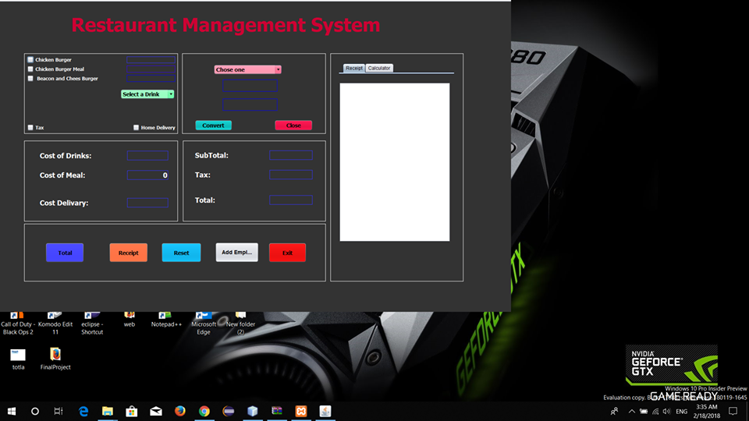>>It’s the main Interface of our application:

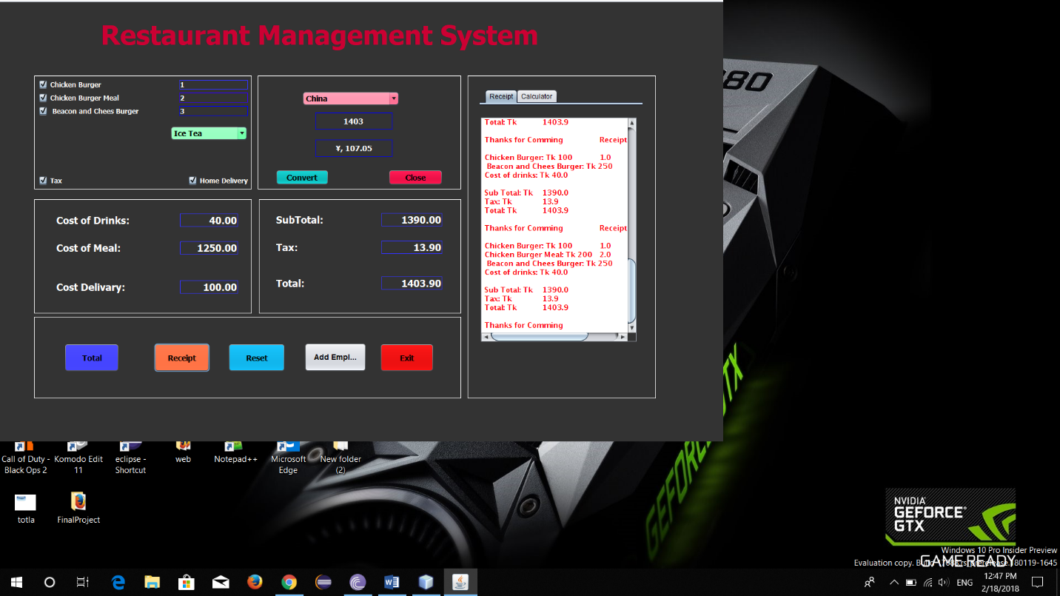

>>Here’s the Registration interface of our system:

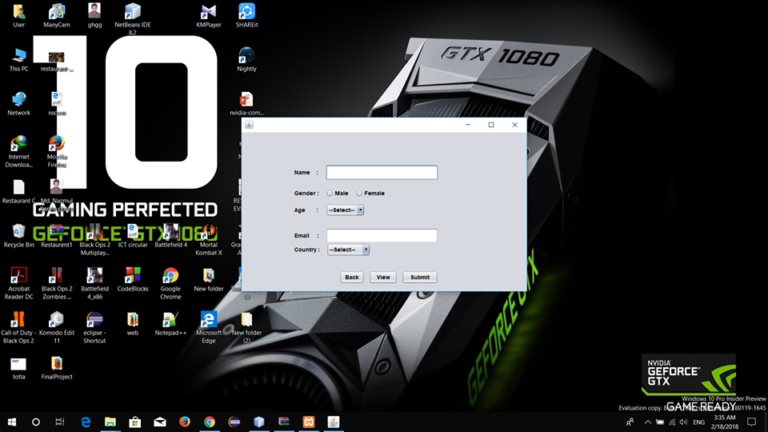

>>Registration info’s are saved in DB like below:

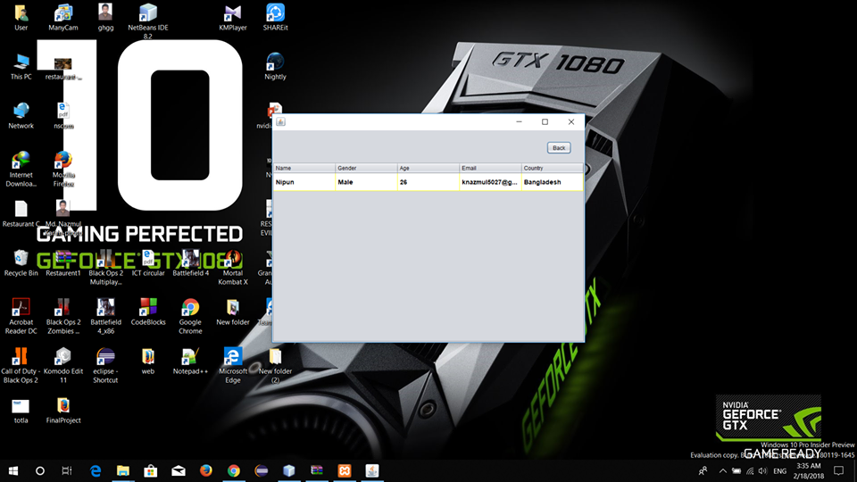

>>These are the different views of our system:

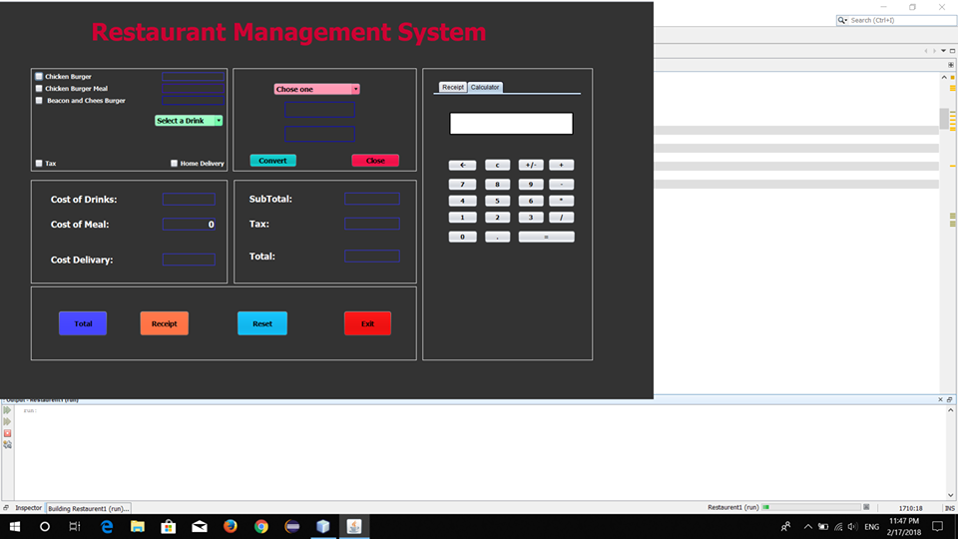

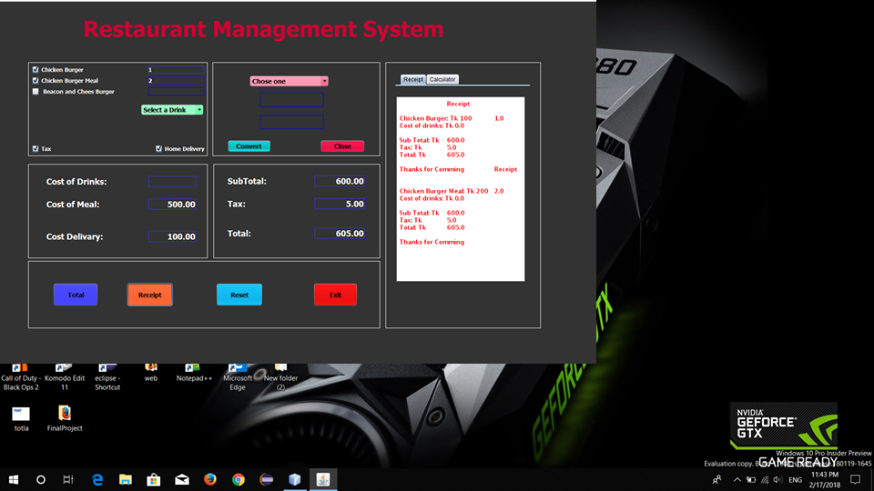

>>Coding section of our System:

>>This sections declare all the variables:

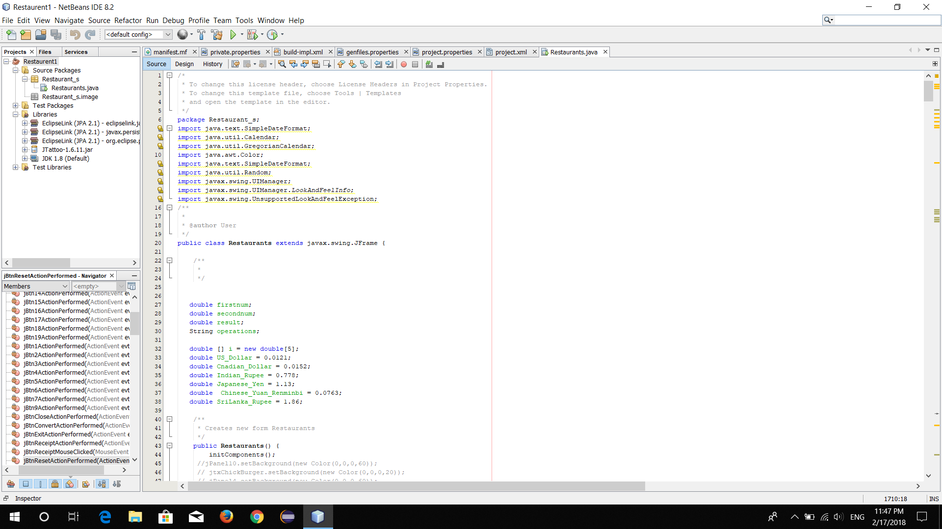

>>This section is for Checkbox of Meals:

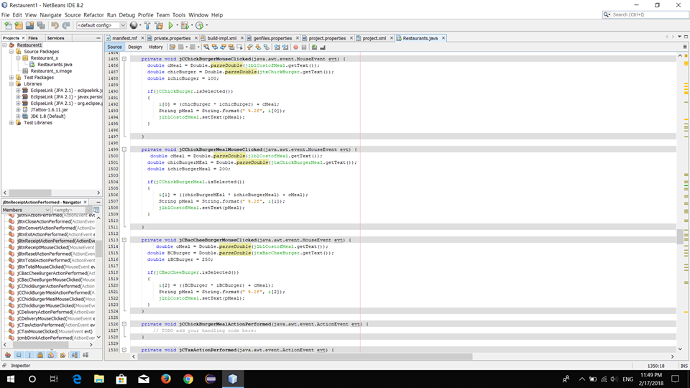

>>This sections generates the functionality of TAX

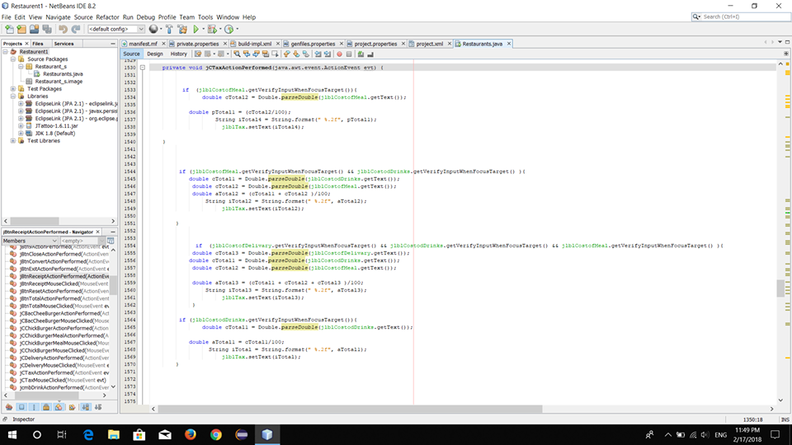

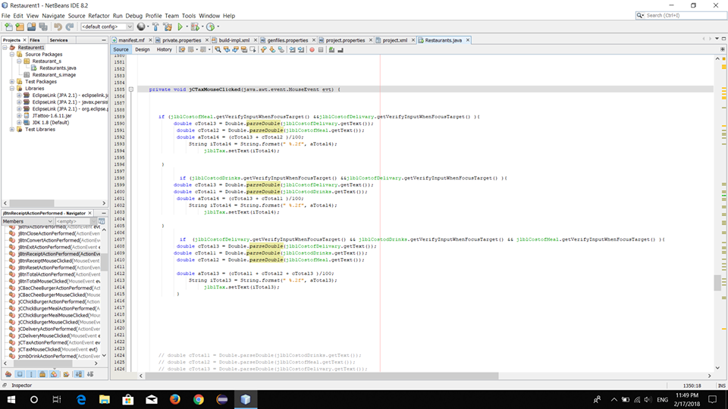

>>This section provides the Home Delivery function:

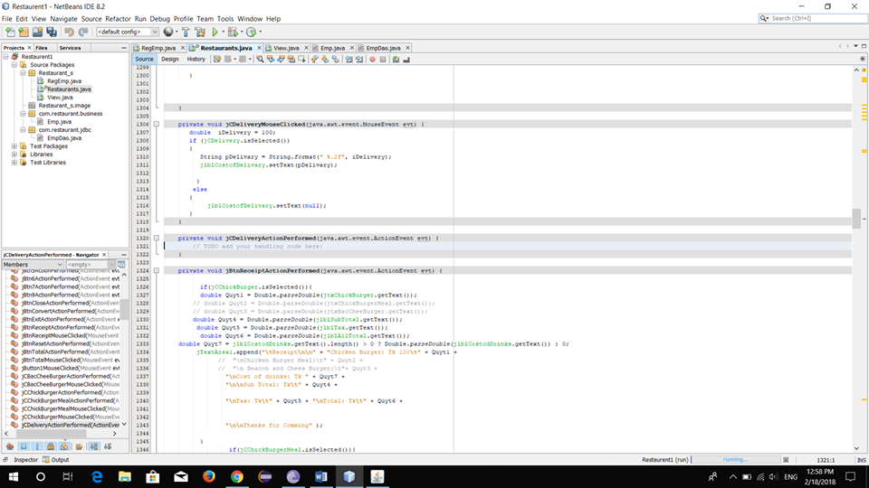

>>This section provides total Calculation functionality:

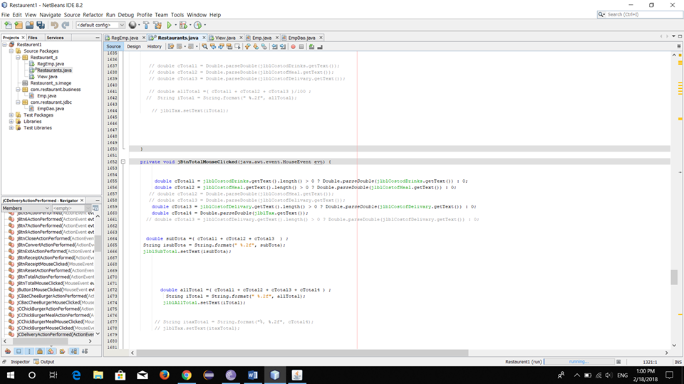

>>This section provides the functionality of Currency Conversion:

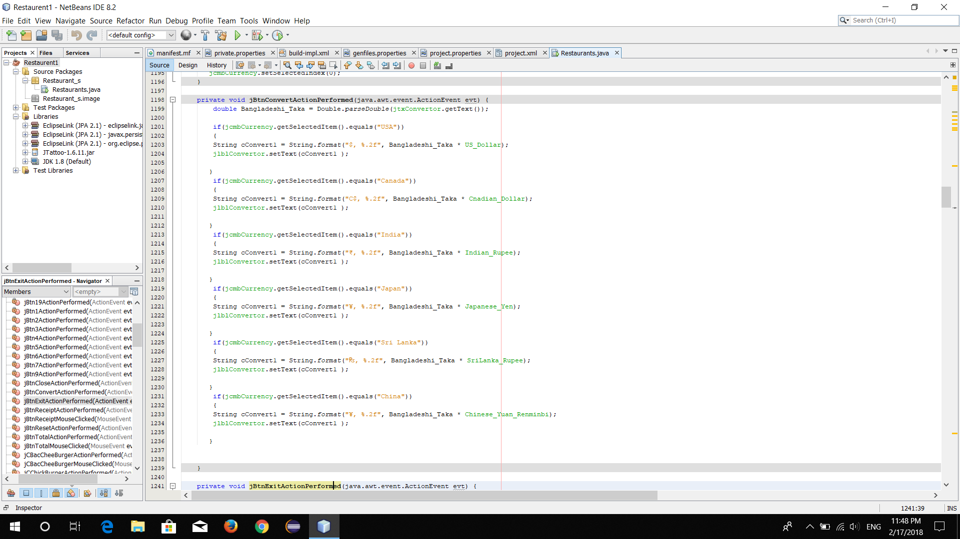

>> This section provides the functionality of Money Reception:

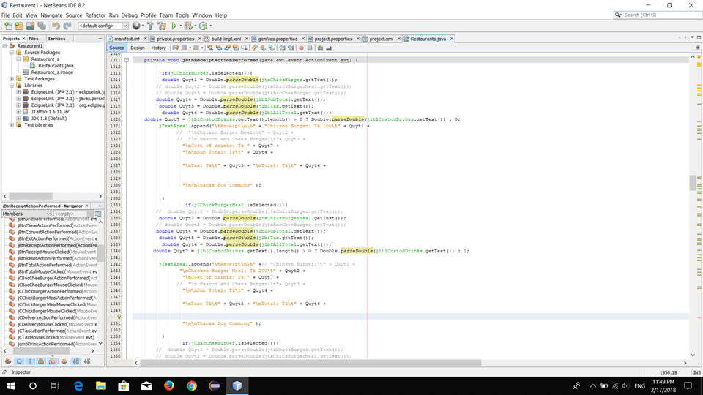

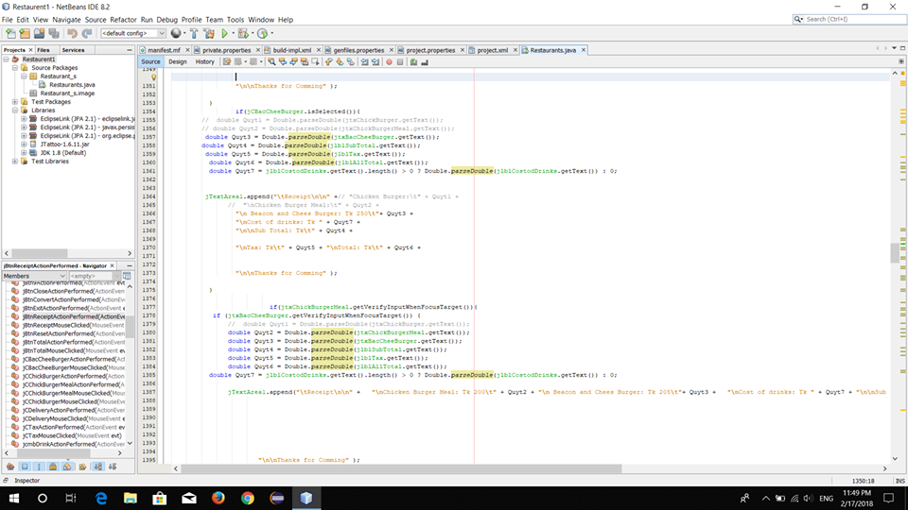

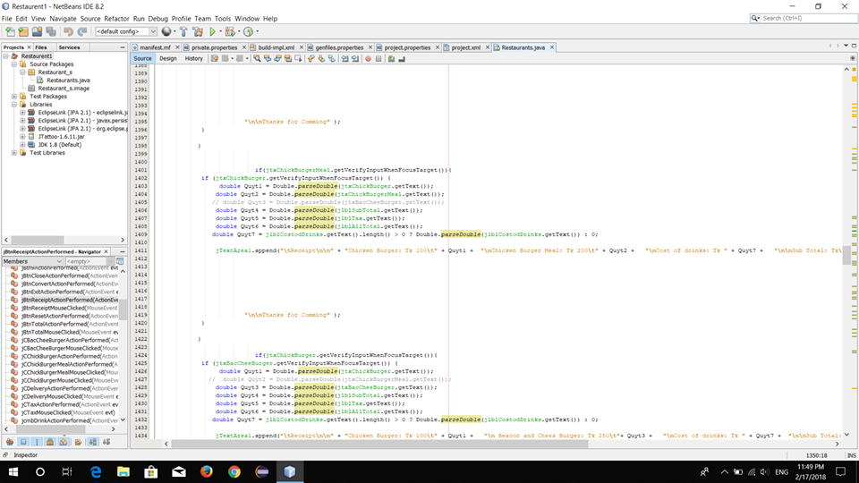

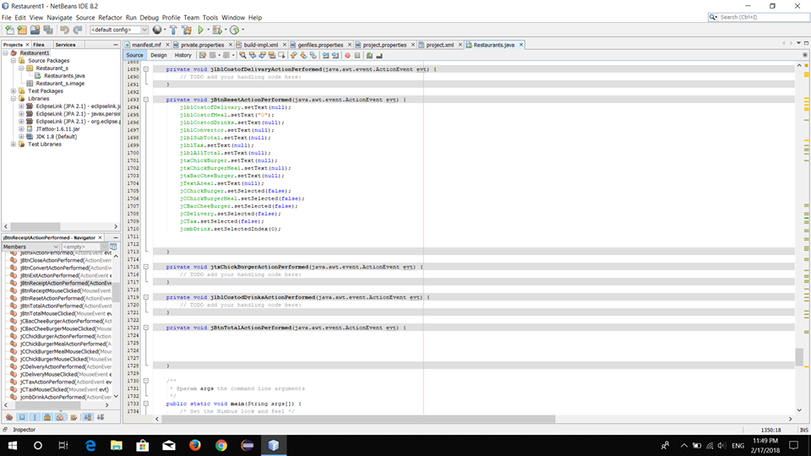

>>This section provides the functionality of Calculator:

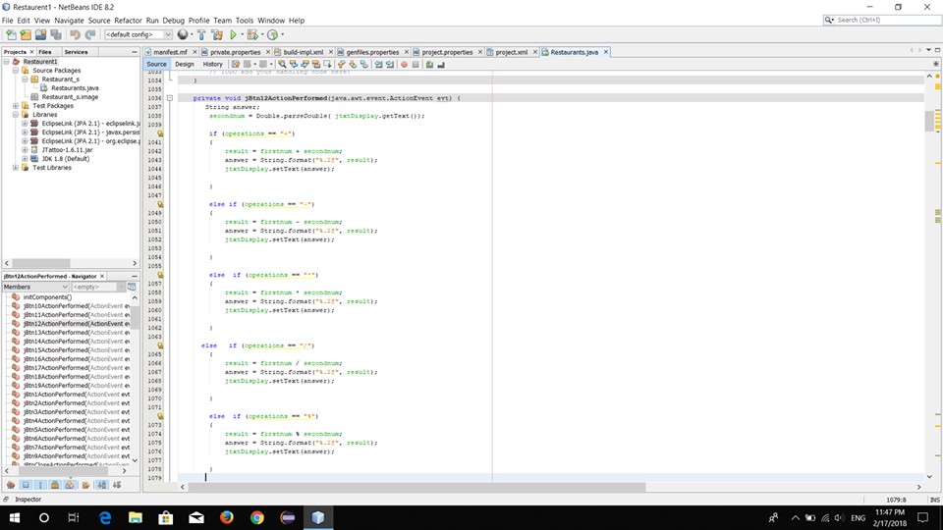

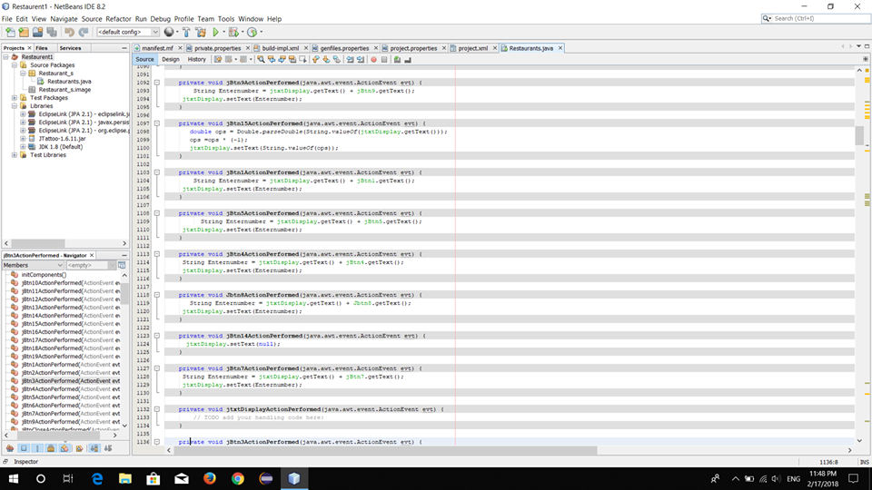

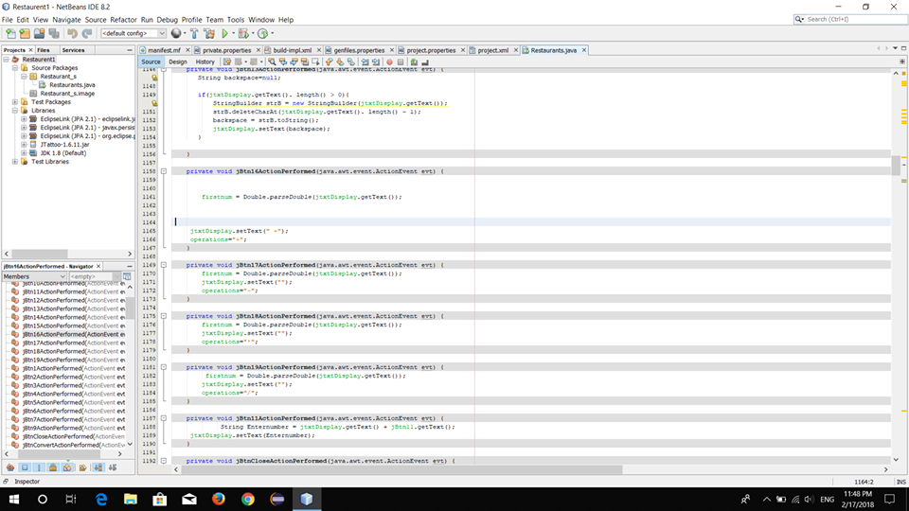

>>This section provides the functionality of Login:

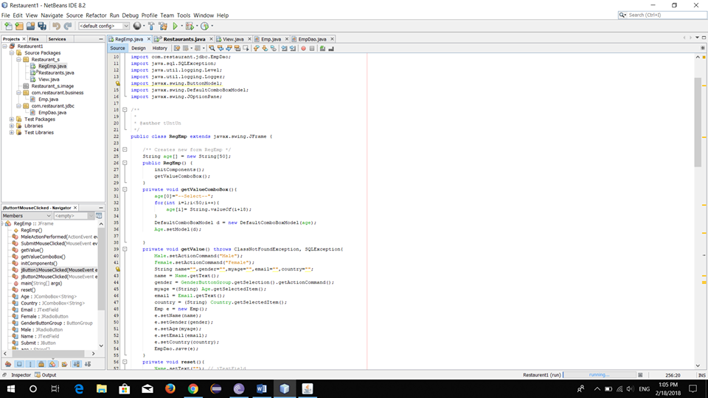

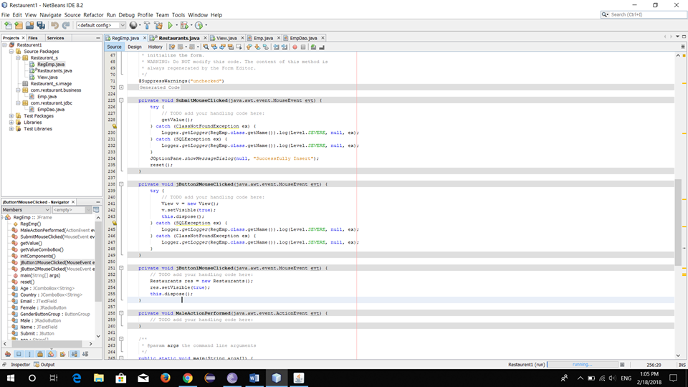

>> This section provides the functionality of View Submission:

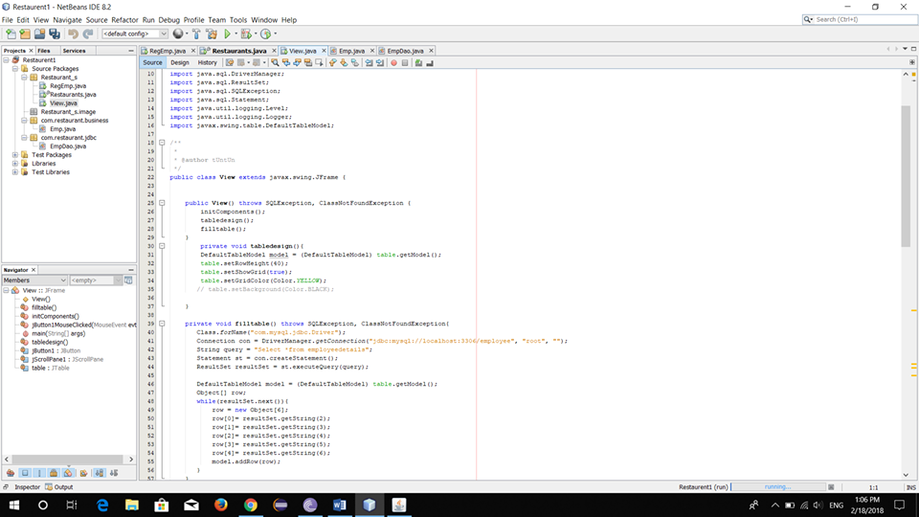

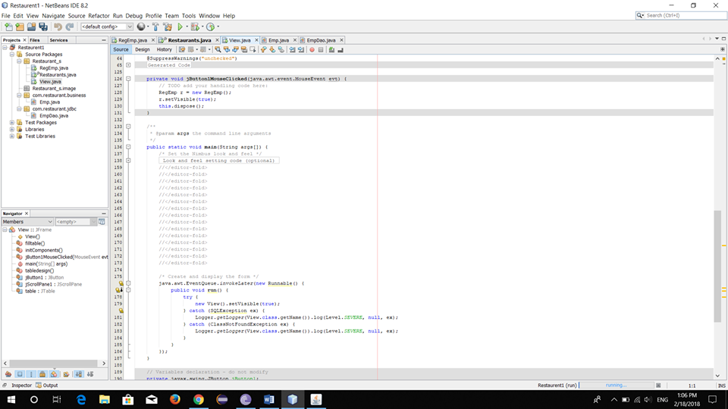

>>This section provides the functionality Registration and MySQL:

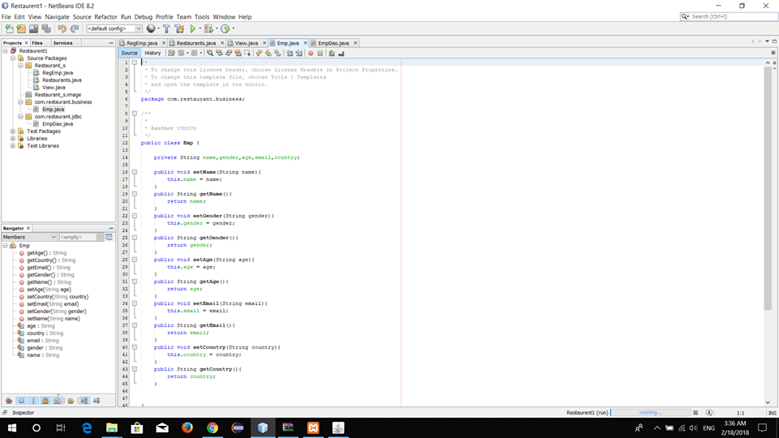

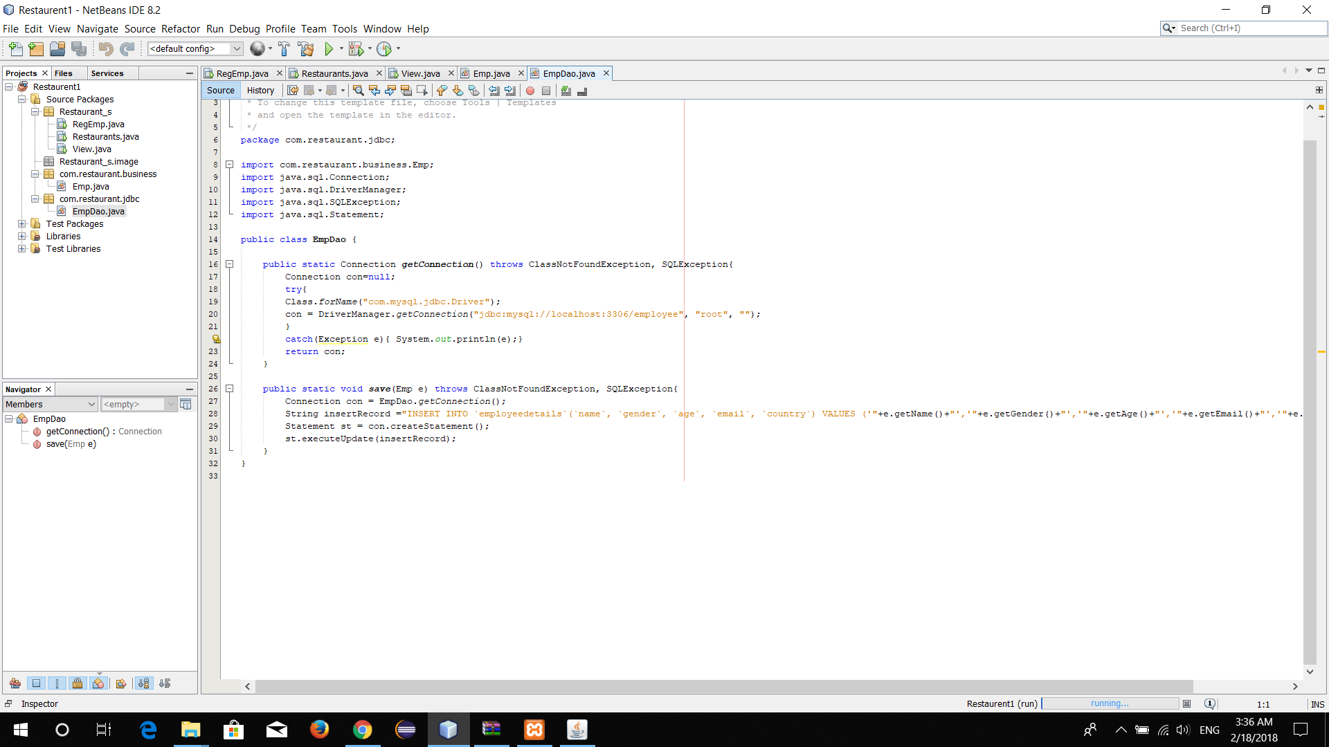

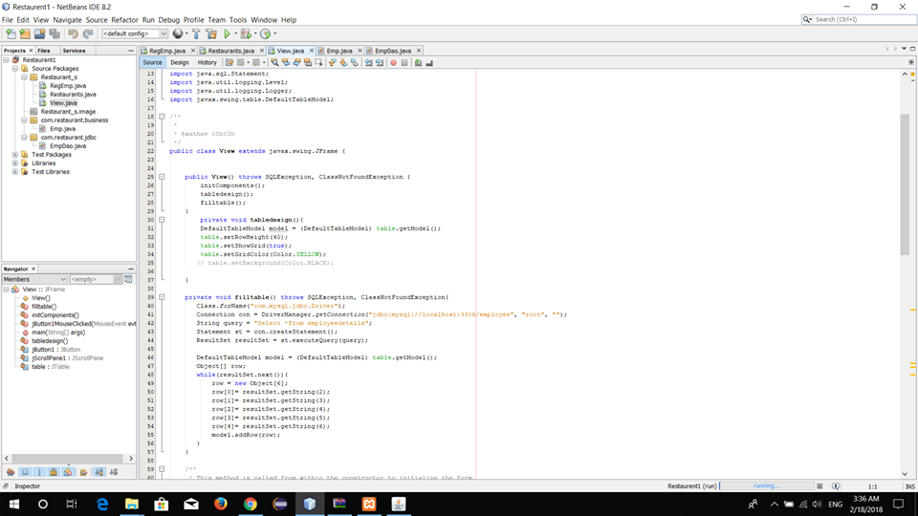

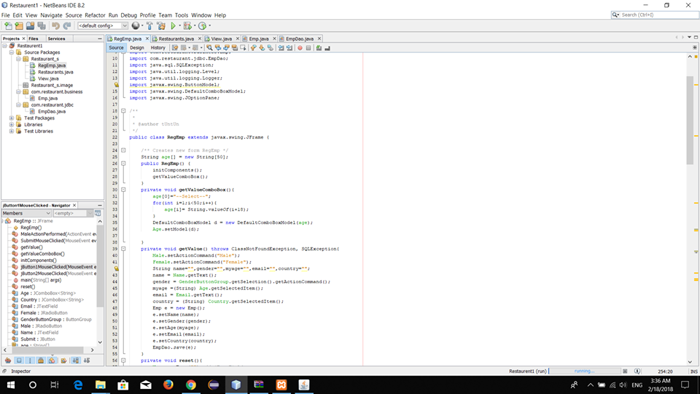

>>This section provides all the buttons:

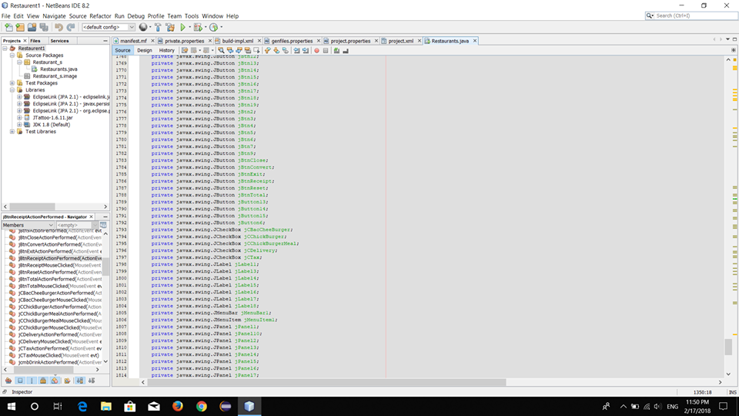

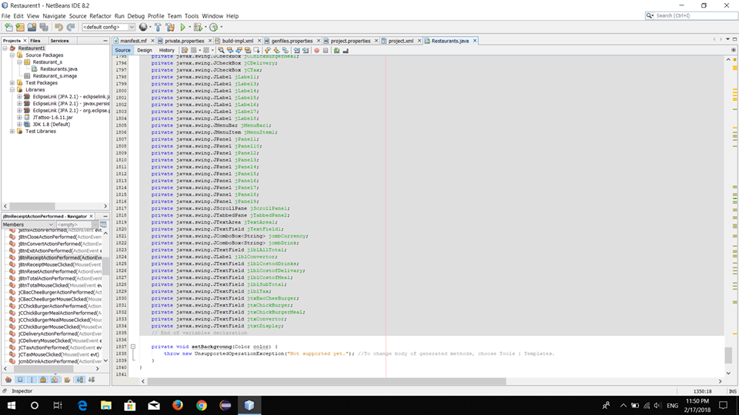

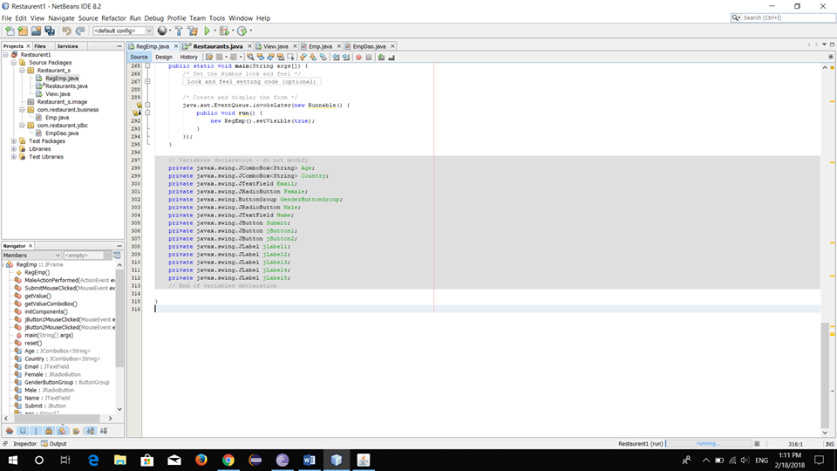

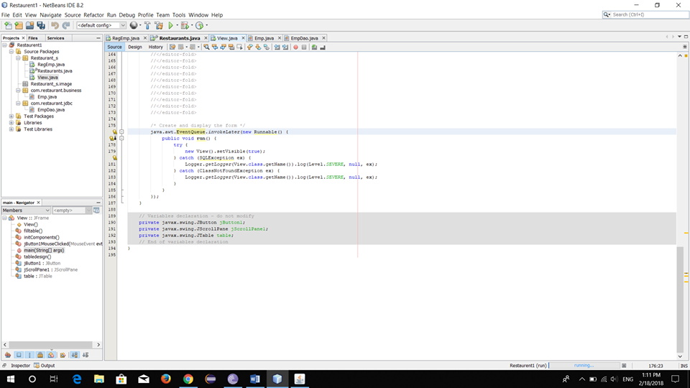

**1.4 Limitations of our system:**

The limitation of our system is that out app is not online based. So admins have to use our system offline cant use it from distance place.

**1.5 Future Work:**

We have tried at best as possible to give them a best solution with our capability and patience. In this solution, some limitations may have found. But we have tried to overcome the limitations in future as per as possible. We will try to add the feature of online version of our system. We will try add the printing Bills functionality in our system. We will try to make our app more flexible.

**1.6 Conclusion:**

We tried our best to provide all the necessary information needed for implementing the Restaurant management system in our report.